**Estimating Bioenergy Feedstock Water Footprints Using a Database and System Dynamics Approach**

*Daniel Inman, Ethan Warner[1], Dana Stright, Jordan Macknick, Corey Peck*

National Renewable Energy Laboratory

15013 Denver West Parkway

Golden, CO, USA 80401

Abstract (245/250 words):

Increased biofuel production has prompted concerns about the environmental trade-offs of biofuels compared to petroleum-based fuels. Biofuel production in general, and feedstock production in particular, is under increased scrutiny because of the impact that large-scale agricultural production has on rural water supplies.

A review of the water footprinting literature helped highlight limitations to current approaches to assessing biofuel feedstock water footprints. In general, most approaches are limited in their capacity to assess the water footprint across multiple stocks (e.g., vadose zone, surface, and ground water stocks). Many models are geographically aggregated, have limited representation of many agricultural feedstocks, and minimal flexibility to perform scenario analysis. We developed a database framework and system dynamics model to assess the water footprint for a wide variety of crops across the U.S in an effort to better understand the water footprint implications of biofuel production in the U.S.

Our model produces results at a high temporal and spatial resolution by using a rich spatial database composed of detailed climate, soil and plant physiological data. Our evaluation of corn and soybeans, as example biofuel crops, showed coverage of green and blue water use across major agricultural areas aggregated to multiple geographic levels. The model’s green water footprints were comparable to existing research. In contrast, blue water footprints were higher due to assuming that irrigation to achieve full potential yields occurred. We were agnostic towards actual irrigation practices, but multiple alternative scenarios could be easily run in our water footprinting model.

Header (200 characters): [To be determined]

Keywords: water footprinting, agriculture, green water, blue water, biomass, bioenergy, sustainability

Main Paper (~5000):

**1. INTRODUCTION**

*1.1. Water Scarcity*

Water issues are important at present, but are of even more pressing concern for agriculture in the future. Production of biomass for food, feed and fiber requires about 86% of the global freshwater use.(1) Water use from agriculture can make up more than 90% of water withdrawals in some developing countries.(2) Agricultural water use competes with other uses such as municipal supplies for drinking and industry in many parts of the world.(3) Balancing multiple competing uses for limited water supplies potentially has major consequences if not done properly. For example, aquatic environments show signs of decline and degradation due in part to how water is managed in many parts of the world.(4) The competing uses for water to meet basic human needs will be challenging in the coming decades.(5, 6) The diversion of surface and ground water without negatively affect freshwater ecosystems performing ecological functions will be more difficult to avoid.(4)

Already scarce water resources in some world regions will face future stress from population growth and climate change.(7) In 2005 it was estimated that about 35% of the world population dealt with long-term water shortages.(8) UNESCO estimates that water shortages are already a constraint on economic growth in several locations such as India, China, and Australia.(2) Projections by UNEP(9) are that by 2025 most of the global population will be living in areas experiencing periodic water shortages. Concern over whether the food, feed and fiber needs in the future can be met in regions with limited water resources are substantial,(4, 10-13) given projections of a world population of 9.6 billion people by 2050.(14)

In the U.S., the geographic focus of this study, agricultural areas already undergo regular periodic drought conditions. Parts of states such Minnesota, Kansas, and Nebraska in 2013 underwent moderate to extreme drought conditions.(15) Simultaneously, as climate changes, the frequency of droughts are projected to increase in parts of some U.S. regions such as the southwest, Rocky Mountain states, and plains states.(16)

*1.2 Bioenergy and Water Consumption*

*2.2. Defining Water Footprinting*

Our analysis uses the following definition of water use from the U.S. Geological Society to avoid confusion (USGS, co.water.usgs.gov/infodata/wateruseconcepts.html):

“Water in the broadest sense, pertains to the interaction of human activity with and its influence on the hydrologic cycle and includes elements such as self-supplied withdrawal, public-supply delivery, consumptive use, wastewater release, reclaimed wastewater, return flow, and instream use. In a restrictive sense, water use refers to water that is actually used for a specific purpose, such as for domestic use, irrigation, or industrial processing.”

“Offstream water use occurs when water is withdrawn or diverted from a ground- or surface-water source for public-water supply, industry, irrigation, livestock, cooling for thermoelectric power generation, mining and domestic purposes.”

“Instream water use occurs when the water remains in the stream (surface water) or aquifer (ground water) during use.”

Water is considered consumed if the part of water withdrawn evaporates, transpires, is incorporated into products or crops, is consumed by humans or livestock, or otherwise removed from the immediate water environment for the remainder of one hydrologic cycle (USGS, co.water.usgs.gov/infodata/wateruseconcepts.html).(17) Water consumption for biofuels includes application of water through irrigation, naturally available water as soil moisture that can be used by crops for growth, but excludes run-off that can be available for other uses. Water consumption and its effects have been measured differently across studies.(18)

Water footprinting characterizes total water consumption along with the sources of the water consumed for the purposes of this analysis. Therefore, we consider both “green” and “blue” water consumption in this paper. Green and blue water are defined in line with other literature such as Yeh et al.(18), Hoff et al.(19), and of Rockström et al.,(20):

“… green water is the soil water held in the unsaturated zone, formed by precipitation and available to plants, while blue water refers to liquid water in rivers, lakes, wetlands and aquifers, which can be withdrawn for irrigation and other human uses. Consistent with this definition, irrigated agriculture receives blue water (from irrigation) as well as green water (from precipitation), while rain-fed agriculture only receives green water. Rainwater harvesting is at the interface of blue and green water. Catching runoff and storing it in small reservoirs (or possibly underground) is interpreted as blue water management, enhancement of infiltration and storage of rain in soil as green water management.”

Blue water withdrawn from aquifers and surface water can be consumed or released when applied. Instream use removes water through incorporation into the crop, evaporation, and evapotranspiration. Outstream use is water released into the environment without quality changes and therefore can be used elsewhere for agriculture, industry, and drinking water. Green water is only considered to be used consumptively.

In our study we specifically differentiate “full growth” water consumption for a given climate from “actual” water consumption. Actual water consumption represents what a farmer applied and is used by an agricultural crop. Actual water consumption may be lower than “full growth” water consumption to obtain desired yields, depending on the circumstances,.(21) For example, farmers may deliberately not irrigate if local water resources are restricted (e.g., by physical availability, lack of irrigation infrastructure, or by public policy) or agricultural prices are too low make irrigation cost-effective. Literature on total water consumption discussed below is mostly based on evaluating self-reported blue water use combined with green water use estimates. Our study does not evaluate actual water consumption because the social and economic drivers of such decisions would be difficult to model for any particular location at a given point in time.

2.2. Existing Water Footprinting Models

Bioenergy production generally consumes more water than gasoline production.(22, 23) Bioenergy systems consume water all along the supply chain, but the major uses of water occur in the cultivation of the biomass feedstock and biomass conversion phases of bioenergy production.(23) The focus of this study is on agricultural biomass production. In feedstock cultivation water is typically lost to the atmosphere through evapotranspiration (i.e., a combination of evaporation and transpiration) during the production of cultivated feedstock. Many recent studies indicate that considerable improvements can be made in efficiency of water consumption in the production of agriculture and bioenergy crops.(22, 24-26)

The increased use of lignocellulosic feedstocks to meet human needs for food, feed, fiber, and energy is one opportunity for improving the efficiency of water consumption of current agricultural and bioenergy systems. Some perennial energy crops could reduce overall water use if grown on extensively managed land such as arable fields being intermittently as pasture for grazing animals.(27) Perennial crops could improve soil water retention and lower soil evaporation, relative to an annual crop and depending on location and climate, while redirecting unproductive water evaporation and runoff .(26, 28) Annual cropping systems that leave residues on the ground can also provide soil water retention benefits. Lignocellulosic based bioenergy systems can use a range of agricultural, industry, and forestry related wastes and residues have little to no direct claims on water consumption and are higher yielding feedstocks.(28) Removal of wastes and residues may have implications for the hydrological cycle because water is used in their growth, but their impacts depend on prior use. Another opportunity to improve the efficiency of water consumption is the use of land types unavailable for the typical agricultural production (e.g., unirrigated degraded or marginal lands) where the use of a lignocellulosic crop would improve soil water retention.(28)

*1.3. Bioenergy and Water Scarcity*

Understanding the water consumption of multiple bioenergy feedstocks is important for determining the impacts of expansionary bioenergy has on water resources. As water is diverted to production of biofuel feedstocks, the water availability for food, feed, and fiber production could decrease.(29, 30) Increased biomass production could come with increased competition for water in critical areas.(23) For example, Berndes(17) reports that a large-scale expansion of bioenergy plantations would lead to a large increase in human water use through evapotranspiration that is potentially as large as existing water consumption from agricultural land.

Water availability already imposes some barriers on the expansion of bioenergy without conflicting with food, feed, and fiber production. Currently, water availability is not a major constraint to bioenergy production in some countries such as such as Brazil, Indonesia, and Canada.(26) Some countries are not facing major water constraints, but countries such as the US are projected to withdraw more than 25% of available surface and ground water reserves.(26)As noted in section 1.1, many countries such as South Africa, China and India are already facing water scarcity issues that impose a constrain on large-scale bioenergy production.(26) In the future, climate change and population growth may exacerbate these barriers to available water. An increase of demand for food in combination with a shift from fossil energy towards energy from biomass puts additional pressure on water resources. All production must come from available water resources, so sustainable intensification by increasing the utilization efficiency of existing water resources would reduce the risk of conflicting with other uses.(27)

**2. REVIEW OF CURRENT WATER CONSUMPTION MODELS AND ASSESSMENT METHODS**

*2.2.1. Penman-Monteith Method*

The underlying set of equations that we use in our model are based on the Food and Agriculture Organization’s (FAO) Penman–Monteith method.(21) This method is a well-established crop evapotranspiration model using plant physiology, soil data, and climate data to calculate irrigation requirements.(21) Many studies (e.g., Gerbens-Leenes et al.(31) and Hoekstra et al.(32)) use forms of this method to calculate crop water consumption. The Penman–Monteith method estimates evapotranspiration as the product of a reference crop evapotranspiration (ETo) and a crop coefficient (Kc), as shown in the equation below.

$${ET}_{C}=K_{C}*{ET}_{O}$$

ETc is total evapotranspiration (mm day−1) from a crop “c”. Kc accounts for plant characteristics such as albedo and crop height that distinguish a crop from the reference surface. Kc represents a crop based constant that varies from 0 to 1. ETo represents the reference crop evapotranspiration (mm day−1). The ETo characterizes climate effects and is based on a calculation using temperature, solar radiation, wind speed, and relative humidity as shown in the equation below.

$${ET}_{O}=\frac{0.408Δ\left(R_{n}-G\right)+γ(\frac{900}{T+273})u_{2}(e_{s}-e_{a})}{Δ+γ(1+0.34u_{2})}$$

* Δ = slope of the vapor pressure curve (kPa per ◦C)
* T = average air temperature (◦C)
* γ = psychrometric constant (kPa per ◦C)
* es = saturation vapor pressure (kPa)
* ea = actual vapor pressure (kPa)
* Rn = net radiation at the crop surface (MJ per m2 day)
* G = soil heat flux (MJ per m2 day)
* u2 = wind speed at 2 m (m per s).

*2.2.2. Public Modeling Systems*

Our literature review found several publically available modeling systems based on the Penman-Monteith method.(21) FAO’s CROPWAT model(33) formulizes the Penman-Monteith method into a model in which users can input data to the equation to calculate crop water requirements and irrigation requirements based on soil, climate and crop physiological data. CROPWAT is a platform for calculations and does not contain its own datasets. FAO offers other sources of data such as CLIMWAT for climatic data that includes more the 5,000 stations globally.

A model closely related to CROPWAT, the Water Footprint Assessment model (Water Footprinting Network, <http://www.waterfootprint.org/tool/home/>), takes global climatic, soil, and plant physiological data to evaluate water consumption. The Water Footprint Assessment model provides water footprints (including blue and green water consumption) of multiple agricultural crops, industrial, and drinking water sectors on a global, country, or water basin level. Higher resolution estimates of water consumption are not available currently, but the model continues to be further developed.

A model similar to the Water Footprint Assessment model is the Consumptive Use Program+ (CUP+)(34). CUP estimates calculate crop water requirements and irrigation requirements based on soil, climate and crop physiological data. The application has built in capacity to study the impact of climate change on water requirements and irrigation water needs. Unlike CROPWAT, CUP+ contains initial climate, soil, and plant physiological data for assessment. Unlike the Water Footprinting Assessment model, CUP+’s assumptions (e.g., wind speed and average temperature) can be modified by the user. CUP+ obviously has limited its scope to modeling the state of California.

Several existing tools/databases exist for assessing other aspects of water use such as water erosion of soil (e.g., are available WEPP(35)) and water flows in and out of soil (e.g., DAYCENT/CENTURY(36)), but do not estimate water consumption.

*2.2.3 Modeling and Assessment Strengths and Weaknesses*

The recently growing literature modeling bioenergy water use has raised awareness of the importance of increasing water consumption to meet bioenergy production.(17, 28, 32, 37, 38) Drawing sufficiently general understanding of the water impact of bioenergy water use from existing literature is hampered by the differences in existing literatures scope, system boundaries, definitions, and methods.(39) Decision-making based on existing literature is difficult because of the complexities of local soil, climate and biological considerations preventing water use estimates at multiple geographic levels and feedstock diversity in conjuncture with those local conditions.

Some recent studies only accounted for water that is applied through irrigation (i.e., blue water) in their analyses.(22, 40, 41) Irrigation water is an important water resource, but about 80% production of global agriculture and 85% of US production of corn is exclusively rainfed (i.e., green water).(22, 42) T Analyses only accounting for blue water overlook a large portion of overall water consumption from rain water. Also, green water consumption can influence the availability of blue water if not allocated to crop production or other uses. (23) For example, increases in green water use can increase the time needed for aquifers to recharge their water storage. Many of the initial water footprinting analyses only accounting for blue water in these initial efforts. These initial efforts were eventually followed by studies that evaluated both green and blue water. (37)

Recent studies considering blue and green water consumption often lack high spatial resolution. Results are usually aggregated to global, national, and, at least for the U.S., the state level. The lack of high spatial resolution gives the impression of that water consumption is consistent over the evaluated geographic area when water consumption is likely highly variable. Water consumption variability can be traced to differences in crop management, crop physiology, local climate and soil conditions. These sources of variability are further complicated by a temporal dimension represented by the season and changes in climate.

Existing models and analysis rarely consider alternative non-historic conditions (e.g. climate change) that might impact future bioenergy water consumption. Potential alternative future conditions are particularly important for understanding the future effects of policies and decision making around multiple crop options and crop water use management practices for bioenergy feedstocks.

Bioenergy systems are fairly complex and variable due to the multiple available feedstocks and energy carriers. A generalized outline of the multiple bioenergy production pathways, including commercial and developing systems, are marked with red boarders in Figure 1. Currently, bioheat and biopower are typically produced from lignocellulosic crops and biofuels from oil, sugar and starch crops. Other food, feed, and fiber commodities cover non-biofuel related agricultural crop categories (i.e., fiber, forage, fruits, vegetables, nuts, and other).

The diversity in bioenergy feedstocks has important implications with regards to managing water resources. Making choices between potentially differing feedstocks that could achieve similar ends (e.g., policy requirements), with different water consumption implications necessitates the ability to evaluate and compare these multiple routes. Many existing water consumption studies have been limited in the scope of crops evaluated and thus inhibit multi-crop comparisons. Our water footprinting tool presented in section 3 of this paper evaluates blue and green water consumption from U.S. agricultural feedstocks from each category shown in the figure. The water footprinting model in this paper is currently limited by agricultural crop data from STATSGO2 and climate data from Cligen, (43) but soil and climate data sets from other sources can be substituted

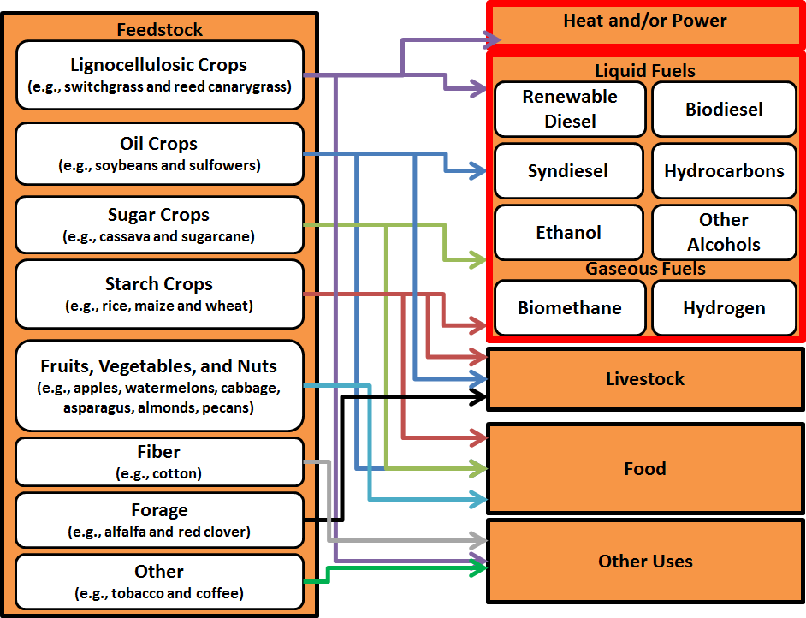

**Figure 1.** Pathways of agricultural feedstock to energy, food, feed and fiber uses.

**3. DATABASE FRAMEWORD AND SYSTEM DYNAMICS APPROACH**

*3.1. Overview of the Tool*

We developed a water footprinting model that contains a system dynamics (SD) component and a soil and climate database framework in order to address existing weaknesses in the literature and modeling efforts. SD is an approach to framing, discussing, and understanding the behavior of complex systems over time. SD uses internal feedback loops, stocks and flow, and time delays to model this behavior. SD models can be powerful tools for generating and communicating important insights about complex systems to the public,(44) and SD has long been used to examine and inform a wide variety of public policy questions and applications.(45) See supplemental information (SI) for additional information about SD. The SD component was created using the STELLA Version 9.1.4 software package (ISEE Systems, Lebanon, New Hampshire) using a stock-and-flow structure.

Figure 1 illustrates the water footprinting model’s macro data process. A detailed figure documenting the micro level data process can be found in the SI. The water footprinting model consists of four main components including the database framework for managing data, the Stella model, a Visual Basic for Applications automation script, and visualization of results. The database structure provides a storage and query environment for processing raw data, generating model inputs and storing outputs for visualization of results. . The SD model uses exogenous climate and soil data inputs to calculate blue and green water consumption metrics. Model execution and data processing management between the database and the model is automated by a Visual Basic for Applications (VBA) module which generates model inputs and outputs using Open Database Connectivity and Microsoft Query language. The blue and green water metric outputs generated for independent spatial locations across the US are stored in the database and results are visualized using Tableau and ArcGIS.

*3.2 Overview of Data Sources, Processing and Management*

The water footprinting model currently uses Cligen(46) for climatic conditions and STATSGO2(43) for soil conditions, and National Agricultural Statistics Service crop planting and harvesting data.(47, 48) Cligen is stochastic climate data simulator that generates daily estimates of precipitation, temperature, dew point, wind, and solar radiation. Cligen uses monthly parameters (e.g., mean, SD, and skew) derived from historic measurements to create daily climate estimates. For the water footprinting model inputs, the Cligen simulation was automated to produce 30 years of daily climate data for 2648 stations across the US. The raw data output from the simulation was extracted, loaded and transformed into the database framework. Using database query language, exogenous climate model inputs are generated by calculating averages of Cligen daily data by month for precipitation, temperature, dew point and wind speed. The model inputs contain 365 daily data points for each of the 2648 US stations for each metric.

STATSGO2 is a generalized 1:250,000 resolution soil dataset. STATSGO2 data metrics are queried based on the National Resource Conservation Commission (NRCS) soil mapping units and spatially joined to the Cligen station locations. Soil metrics are extracted for each cligen spatial location and metrics are averaged over the soil horizon and the soil name for each spatially joined mapping unit. Exogenous STATSGO2 soil input parameters used in the water footprinting model include % sand, % silt, % clay, available water capacity, moisture bulk density and crop yields. Field capacity and wilting point are calculated in the database using the pedo transfer functions.

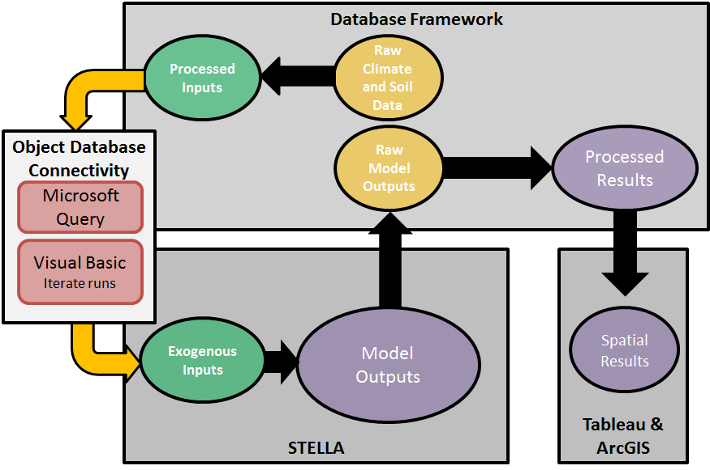

**Figure 2.** Water footprinting model, data processing and management diagram.

A process of runs was developed in Visual Basic for Applications (VBA) to loop through each cligen spatial location, import its associated soil and climate exogenous inputs into the model, run the model and generate output. Within Microsoft Excel, VBA automates the model runs using Microsoft Query Language and Object Database Connectivity (ODBC), and the VBA code integrates the Stella command line to iterate through the runs. Outputs from the SD model runs for each spatial location are processed in the database framework for connectivity to Tableau and ArcGIS for data visualization. Outputs include blue and green water for each crop class in the model including perennial forage, annual forage, corn, feed crop, fiber crop, grain, oil crop, sugar crop, winter grains and soybeans.

*3.3 Why System Dynamics?*

Water footprinting is particularly well suited for study using SD. SD uses cause-and-effect relationships in a dynamic stock-and-flow framework. SD uses historic trends as inputs and for calculating water footprints based on relevant climate, soil, and agricultural cause-and-effect relationships. The tool is flexible in the evaluation of multiple crops simultaneously, using alternative climate and soil input data for multiple geographic contexts. The SD model then provides disaggregated water consumption results based on these inputs.

. SD can be transparent and involve stakeholders in running the model and scenario development for shared exploration of water issues. Relatively, the model is simple and user friendly model that could be provided online to the public for anyone with the Stella software. The eventual public release of an SD model would enable access to a flexible and transparent analytic method can help better understand water consumption.

*3.4 Overview of the System Dynamics Model*

The SD model calculates green and blue water consumption for all agricultural crops in which STATSGO data was available. Equations in the Stella model are based on FAO’s Penman-Monteith method.(21) which are based on a modification to the Penman-Monteith method Allen (1998).(21) We are using endogenous calculations for most of the parameters in the Penman-Monteith question. For example, crop coefficient curve can be calculated for each station from exogenous Cligen data instead of just using a standardized crop coefficient curves. By bringing the Penman and Monteith method into a SD framework we are calculating the water footprint for each DT and integrating over the model run.

Figure 3 illustrates the generalized influence diagram of the SD model for calculating green and blue water consumption.

* Orange ovals represent inputs from the processed Cligen and STATSGO data in the database
* Orange diamonds representing controls or switches in the Stella model. Controls are sometimes determined by users in the SD model, but can also be determined endogenously based on soil and climate data or other user decisions.
* White ovals represent important endogenously calculated variables. Rectangular boxes and arrow represent the stock and flow of green and blue water resources (as indicated by the colors used).

Blue water consumption per Mg of agricultural feedstock is estimated using yields and crop evapotranspiration rates. Green water is determined by the available soil water and crop evapotranspiration rates. Available soil water is constrained as determined by average precipitation and soil texture. Crop evapotranspiration is calculated based on an evapotranspiration reference surface and an endogenous or exogenous crop coefficient that depends on user choice. Behind the crop coefficient curve and reference surface calculations is climate and soil input data and other user determined assumptions.

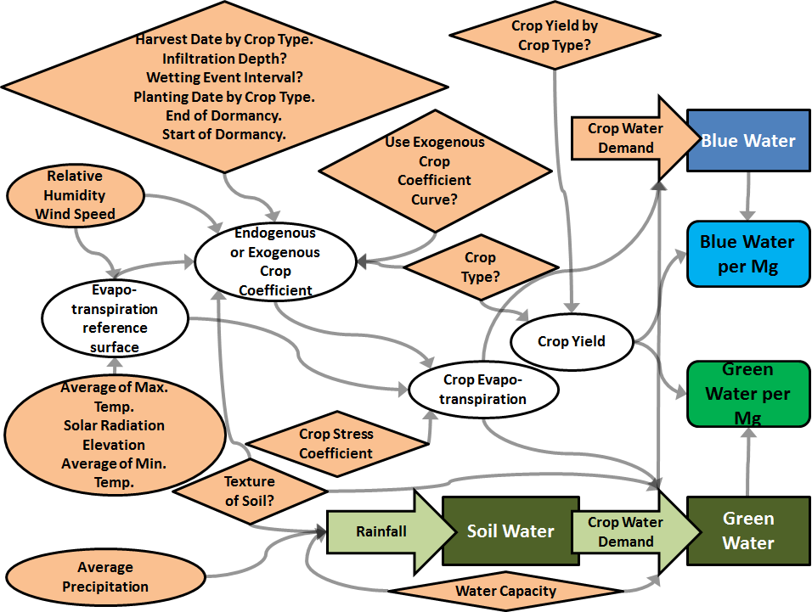

**Figure 3.** System dynamics model overview diagram.

*3.5 Model Verification*

The model was vetted through internal and external review by water footprinting experts. The water footprinting model underwent an external review by May Wu for usability and conceptual validity. Internal review of modeling methods was completed by [???]. Expert vetting allowed for an evaluation of the underlying structure and supporting data sets for plausibility of use in water consumption modeling.

Case study comparisons of water consumption estimates from the literature allowed for further validation of water footprinting model results, at least with regards to green water use. Case study comparisons allowed for the evaluation of plausibility in reference to existing analyses and test the ability to plausibly evaluate aggregate geographic level water consumption based on individual locations (i.e., Cligen stations) available. We focused case study development on well researched agricultural crops used for biofuel, corn grain and soybean.

We compared green water footprinting model results to existing county level and higher resolution water consumption assessments. Ideally the water footprinting model’s results should be compared to site specific cases as represented in the Cligen data used for calculations. However as outlined in section 1.3, options for high geographic resolution water consumption assessment are limited. The following studies with data on maize and soybean biofuel feedstocks were used: Dominguez-Faus et al.,(49) Fingerman et al.,(23) Gerbens-Leenes et al.,(31) King et al.,(50) Mishra and Yeh,(51) and Mubaka and Land.(52) We also discuss blue water footprinting which are inherently not comparable to existing analyses.

**4. ILLUSTRATIVE WATER FOOTPRINTING RESULTS**

*4.1 Discussion of Results and Comparison to Other Studies*

*4.1.1 Water Footprinting Model Station Coverage*

Figure 4 illustrates green and water consumption by station for corn grain and soybeans from out model. The water footprinting tool’s coverage includes major production areas in the Midwest, plains, south, and Atlantic states. Coverage was limited by where spatial explicit climate, soil, yield, and harvesting/planting dates were available so data for locations in the west were unavailable, despite the potential for growing corn and soybean in those areas.

In general, green and blue water consumption matches expectations as they relate to general climate trends over the geographic area and differences between the two biofuel crops. Irrigation requirements by station for both soybeans and corn increased when moving west and south as the climate becomes drier and green water availability is reduced. Soybeans have higher water requirements. Trends in Figure 4 matching trends seen in existing water footprinting literature such as Chiu et al.(53), Gerbens-Leenes et al.(31), and Dominguez-Faus et al.(49)

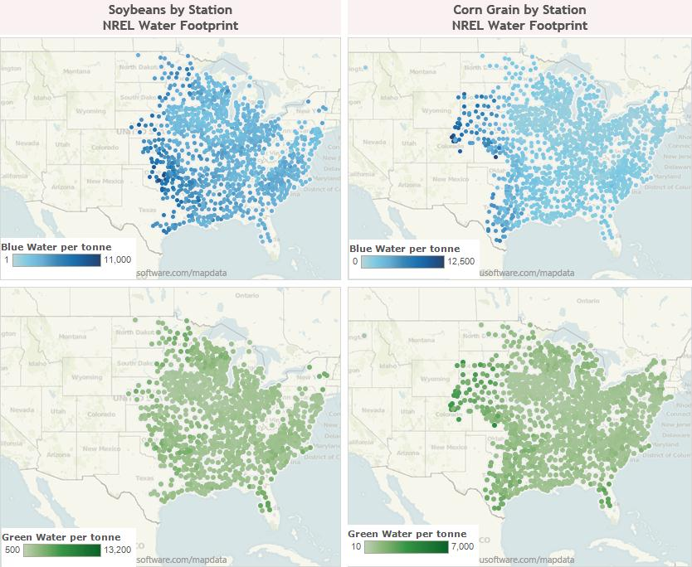

**Figure 4. Water Footprinting Tool Corn and Soybean Station Coverage for Green and Blue Water Consumptions**

*4.1.2 Water Footprinting Model Aggregation to County Level Coverage*

Figure 5 illustrates green and water consumption by county for corn grain and soybeans from out model. The water footprinting tool’s results can be easily aggregated to county and state averages. County level data are not available for every county in a state. For example, Chui et al.(53) corn water footprinting covers many more counties in Midwestern states relative to our water footprinting tool. However, our tool frequently includes several data points within a county (with potential to add more if data is available) that are rolled up into a state average.

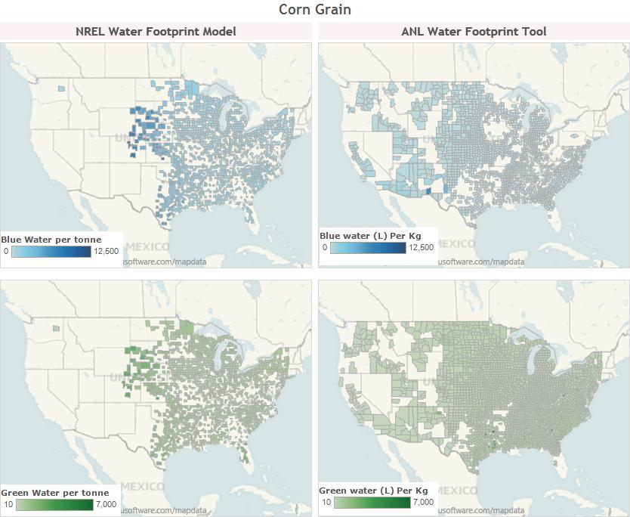

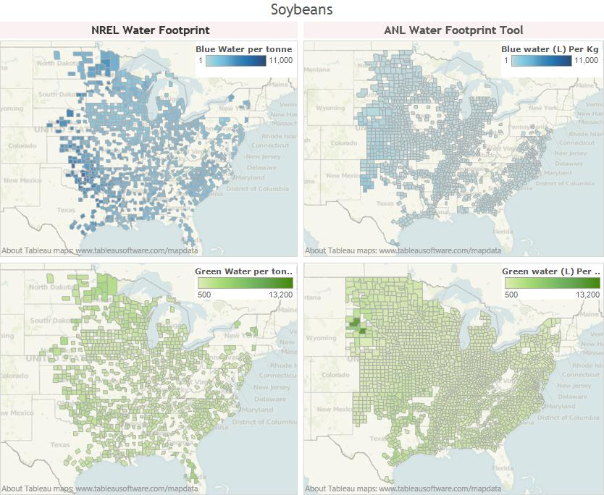

**Figure 5. Water Footprinting Tool Corn and Soybean County Level Coverage for Green and Blue Water Consumptions**

*4.1.3 Water Footprinting Model State Level Distribution*

Distributions of station level blue and green water consumption estimates can be seen in Figure 6. The green water footprints from out tool compare well to existing analyses and models. Some existing analyses estimate green water footprints ranging from around 100-1,200 m3/Mg feedstock depending on the state or county evaluated.(51-53) While less studied, Chiu et al.(53) estimated green water footprints ranges from around 1,000-4,000 m3/Mg feedstock depending on the county. Our water footprinting tool reported green estimates generally within those ranges. Outliers outside of those ranges are possibly due to natural variability that would not be captured in the state and county averages of other analyses. Differences between states are similar when comparing our water footprinting tool to existing analyses. States like Iowa, Minnesota, Wisconsin, and Illinois have higher green water footprints than drier states like Nebraska, Colorado, and Kansas.(51-53) These trends are also reflected in green water footprints for most stations in those states.

Blue water footprinting from our tool differs from existing analyses. Our tool is used to estimates “full growth” water use in order to avoid the socio-economic decision-making behind actual irrigation. “Full growth” water use means that agricultural crops will be irrigated enough to achieve that potential yield. Our blue water footprinting results are inherently going to be higher than many existing analyses use self-reported irrigation estimates ranging from 0-550 m3/Mg for corn grain and 0-1,300 m3/Mg for soybeans.(23, 31, 49-52) Our blue water footprint ranges from X-Y m3/Mg. The implicit assumption under the “full growth” scenario is that farmers have no tolerance for drought and no barriers to access. Our water footprinting tool could be made comparable to other analyses through examination of alternative scenarios (see example in 4.2).

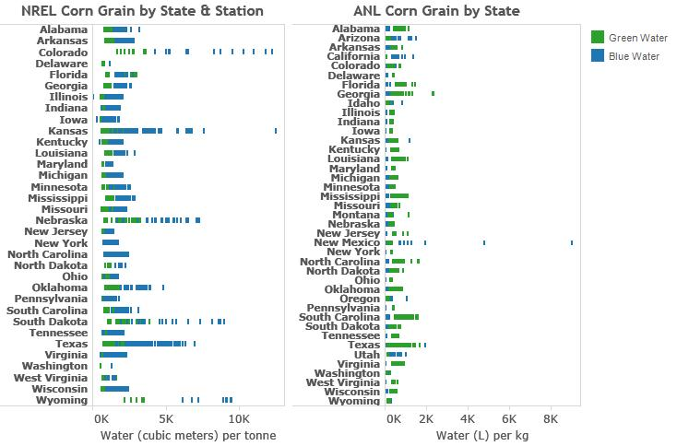

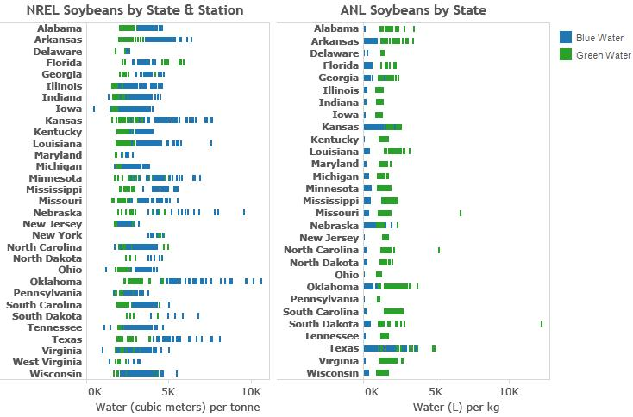

**Figure 6. Corn Grain and Soybean Green and Blue Water Consumption by State. The Water Footprinting Tool is Compared to Chiu et al. (2012).**

*4.2 Water Footprinting Tool Flexibility and Improvements to Policy Analysis*

Our water footprinting tool builds on previous water consumption analyses to provide a platform in which more comprehensive assessment can be completed to better inform decision-makers. The water footprinting model can play an important role in estimating the water consumption impacts of existing policies, but also could anticipating the future implications of existing or proposed policies. As the model currently stands, green and blue consumptive water consumption from multiple agricultural crops at several levels of geographic aggregations could be evaluated in the continental U.S. This scope of assessment would allow more systematic comparison of trade-offs of multiple agricultural crops and produce estimates that fit the geographic scope of policy questions.

The footprinting model can be used to evaluate other geographic contexts at multiple spatial levels. Results from section 4 demonstrate the capability to evaluated county, state, and national U.S. water consumption for commonly studied biofuel crops relative to some existing water consumption analysis. Evaluation of water consumption at multiple geographic levels can be important in evaluating the potential impacts of existing state and national bioenergy policies (e.g., US EPA(54) and EU(55)) and how those policies might interact. There are also potential new opportunities to analyze new policies or aid in sustainability certification of bioenergy projects. In addition to geographic assessment at multiple levels, the water footprinting model also has the potential to be adapted for analysis of water consumption of less well researched regions (e.g., developing countries) of the world. The water footprinting model’s database could be modified for other geographic contexts where climate and soil data for running the model are available.

The water footprinting model was used in this paper to look at two common biofuel feedstocks, but the model has the potential for broader applicability. Besides the ability to assess optimal water consumption of potential crops for biopower, the model can assess a wide array of agricultural commodities. As noted in section 1.4 non-energy crops could be evaluated using the model and therefore could be used for decision-making in food and fiber sectors. The current version of the water footprinting tool is designed to evaluate water consumption in agriculture crops. There is the potential to adapt the database and SD framework to evaluate the water consumption of other energy technologies or water consumption in biomass conversion to fuel, heat, or power.

The model’s dynamic capabilities and adjustable climatic data allow analysis of water consumption changes over time among multiple future policy pathways. Policy analysis used in decision-making frequently requires anticipating the effects of a policy sometime in the future. Therefore, it seems important to be able to estimate the potential water consumption of biofuel feedstocks in the future given expected climatic and demographic changes effecting water resources that are noted in section 1.1. The model can be flexibly altered to represent alternative climatic conditions assuming the availability of data for a given geographic area. These alterations can represent the potential impacts of climate change and allow for better assessment of the water consumption impact of a bioenergy policies in future years.

While expansion or modification of the water footprinting model to new conditions and applications would take time, the SD frameworks provides a flexible and relatively user friendly interface for basic on demand water consumption analysis for many U.S. agricultural crops. The user interface of SD models can be modified to allow users of the model access to different aspects of the water consumption calculations. These controls allow users to quickly make modifications and see the implications of those results in real time.

One example is the opportunity to runs scenarios in a top down analysis of theoretical blue water use compared to self-reported irrigation from the USDA.(56) The water footprinting tool has a risk tolerance factor that represents the yield loss that farmers would be willing to incur. Farmers would irrigate up to that threshold. As noted in section 4.1.3, this risk tolerance is set to essentially zero in default model runs. This yield loss tolerance factor could be modified by state, county, or even station to represent irrigations constraints and farmer’s choices with regards to irrigation. A potential analysis would include comparing actual yields to potential yields for a defined area, calculate the blue water footprint based on a yield loss tolerance factor reflecting actual yields, and comparing the blue water footprint to self-reported irrigation from the USDA.(56)

*4.3 Model Limitations*

The water footprinting model improves on existing analysis and addresses several limitations those analyses of agricultural crop water consumption. However, our water footprinting model is not intended to be a comprehensive tool and is still limited in several respects. Limitations of the water footprinting model can be divided into those inherent in the modeling framework and those inherent in the data used in the model. The water footprinting model’s limitations imply the model’s results should be further scrutinized and carefully considered, but verification by other experts and comparison to previous assessment (i.e., see section 4) implies a level of confidence similar to existing water consumption analyses.

The datasets available for operating the water footprinting model limits its capabilities. The biggest limitation is crop yields and plant and harvesting data from some regions of the country. Another issues is that Cligen climate data is based on a location sampling driven by available stations. This contrasts with STATSGO data that is relatively high resolution and completely covering most of the continental U.S. Cligen station coverage of the U.S. is relatively complete (i.e., several stations in each state), but that does not preclude bias introduced by stations available. Cligen data also does not have the accuracy of a more site-specific geospatial modeling system analysis. The use of Cligen station data implies that modeling of optimal water consumption for the particular station is likely to more accurate and precise. County, state, and national estimates might be biased by the station sampling of the local climate if coverage is low or clustered in a particular area.

The modeling framework of the water footprinting tool also presents two key limitations to water consumption analysis. The Penman-Monteith method equations(21) and the SD model they resides in are parsimonious and readily modifiable by users. However, the climate and soil data management system is more complex than the SD model and would not be easily modified by users inexperienced in database management and model automation.

Finally, as noted in our literature review, the water footprinting tool and many other water consumption analyses are intended to model optimal requirements. In reality farmers may be over or under watering crops depending on circumstances. These circumstances could include already existing local water consumption physical or financial barriers or because best management practices are not in use.

**5. SUMMARY**

Our review of water consumption analysis literature revealed several limitations in existing water footprinting assessment. Water consumption analyses often aggregated of water consumption from multiple sources, aggregated to national and geographic levels, covered a limited set of agricultural feedstocks, and lacked flexibility to alter input assumptions. These limitations present a barrier to a better understanding of bioenergy water consumption. Such an understanding is necessary for decision-makers to evaluate the trade-offs between bioenergy systems, other sources of energy, and other agricultural commodities.

To help address identified limitations in optimal water consumption analysis we developed a water footprinting model based on a database framework running climate and soil data through as SD model. Using Cligen and STATSGO datasets the model’s results and capabilities were demonstrated by comparing maize, soybeans, and cellulosic crop case studies to other data sets and literature. Our evaluation of corn and soybean crops showed coverage of green and blue water consumption across major agricultural areas. Water footprints for those areas were comparable to existing water footprinting research albeit with greater variability owing to the use of station level rather than county or state level data. The water footprinting model’s coverage was not as extensive as reported water consumption due to the lack of spatially explicit data for many states west of the Rocky Mountains. The tool is limited in several key respects by the resolution of available data and the complexity of data management is a barrier to use. However, results were comparable to previous analyses of optimal water consumption.

The tool improves on optimal water consumption analysis is several key respects. The water footprinting models by allowing for reporting at several geographic levels disaggregated over multiple water sources over time. The tool can also evaluate many agricultural feedstocks used for bioenergy and food in current and potential future use. Finally, the tool could potentially be applied to other energy technologies with relatively high water consumption impacts.

ACKNOWLEDGEMENTS

This work was supported by (DANNY or JORDAN PLEASE FILL IN). To our knowledge, the authors do not have any other potential conflicts of interest. Daniel Inman contributed to project scoping, major contributions to model development, and major contributions to the writing of the paper. Ethan Warner provided major contributions to the writing of the paper. Dana Stright provided major contributions to the STATSGO and CLIGEN database framework and minor writing contributions. Jordan Macknick provided major contributions to project scoping and minor contributions to writing. Corey Peck provided minor contributions to model and database framework development. (REVIEWERS TO BE ADDED)

7. References

1. Hoekstra AY, Chapagain AK. Water footprints of nations: Water use by people as a function of their consumption pattern. Water Resources Management. (2007) 2007/01/01;**21**(1):35-48. English.

2. UNESCO. The United Nations World Water Development Report 3: Water in a Changing World. Paris and London: UNESCO and Earthscan (2009).

3. Falkenmark M. Comparative hydrology—a new concept. In: Falkenmark M, Chapman T, editors. Comparative Hydrology An Ecological Approach to Land and Water Resources. Unesco, Paris, France(1989). p. 10-42.

4. Postel SL. ENTERING AN ERA OF WATER SCARCITY: THE CHALLENGES AHEAD. Ecological Applications. (2000) 2000/08/01;**10**(4):941-8.

5. Postel SL, Daily GC, Ehrlich PR. Human Appropriation of Renewable Fresh Water. Science. (1996) February 9, 1996;**271**(5250):785-8.

6. Gleick PH. The human right to water. Water Policy. (1998) 10//;**1**(5):487-503.

7. Pfister S, Koehler A, Hellweg S. Assessing the Environmental Impacts of Freshwater Consumption in LCA. *Environmental Science & Technology*. (2009) 2009/06/01;**43**(11):4098-104.

8. Matti K, Philip JW, Hans de M, Olli V. Is physical water scarcity a new phenomenon? Global assessment of water shortage over the last two millennia. *Environmental Research Letters*. (2010);**5**(3):034006.

9. UNEP. Global Environmental Outlook 4. Nairobi, Kenya: Environment for Development, United Nations Environment Programme, (2007).

10. Fischer G, Shah M, van Velthuizen H, Nachtergaele FO. Global agro-ecological assessment for agriculture in the 21st century. IIASA, (2001).

11. Rockström J, Lannerstad M, Falkenmark M. Assessing the water challenge of a new green revolution in developing countries. Proceedings of the National Academy of Sciences. (2007) April 10, 2007;**104**(15):6253-60.

12. United Nations Development Programme. Human Development Report 2006—Beyond Scarcity: Power, Poverty and the Global Water Crisis New York: United Nations Dev Programme, (2006).

13. Vörösmarty CJ, Green P, Salisbury J, Lammers RB. Global Water Resources: Vulnerability from Climate Change and Population Growth. Science. (2000) July 14, 2000;**289**(5477):284-8.

14. United Nations. World Population Prospects: The 2012 Revision, Key Findings and Advance Tables. Department of Economic and Social Affairs, Population Division, (2013) Contract No.: ESA/P/WP.227.

15. National Drought Mitigation Center. National Drought Summary May 28, 2013. Lincoln: University of Nebraska-Lincoln, the United States Department of Agriculture, and the National Oceanic and Atmospheric Administration, (2013) May 28. Report No.

16. Kenneth S, Gary Y, James N, Brent B. Characterizing changes in drought risk for the United States from climate change. *Environmental Research Letters*. (2010);**5**(4):044012.

17. Berndes G. Bioenergy and water--the implications of large-scale bioenergy production for water use and supply. *Global Environmental Change*. (2002);12(4):253-71.

18. Yeh S, Berndes G, Mishra GS, Wani SP, Elia Neto A, Suh S, et al. Evaluation of water use for bioenergy at different scales. *Biofuels, Bioproducts and Biorefining*. (2011);**5**(4):361-74.

19. Hoff H, Falkenmark M, Gerten D, Gordon L, Karlberg L, Rockström J. Greening the global water system. *Journal of Hydrology*. (2010) 4/30/;**384**(3–4):177-86.

20. Rockström J, Falkenmark M, Karlberg L, Hoff H, Rost S, Gerten D. Future water availability for global food production: The potential of green water for increasing resilience to global change. *Water Resources Research*. (2009);**45**(7):W00A12.

21. Allen RG, Pereira LS, Raes D, Smith M. *FAO Irrigation and Drainage Paper*. Rome, Italy: FAO; (1998). 333 p.

22. Wu M, Mintz M, Wang M, Arora S. Water Consumption in the Production of Ethanol and Petroleum Gasoline. *Environmental Management*. (2009);44(5):981-97.

23. Fingerman KR, Torn MH, O’Hare MS, Kammen DM. Accounting for the water impacts of ethanol production. *Environmental Research Letters*. (2010);5(1):014020.

24. Dornburg V, Faaij A, Verweij P, Langeveld H, van de Ven G, Wester F, et al. Assessment of Global Biomass Potentials and their Links to Food, Water, Biodiversity, Energy Demand and Economy. Bilthoven, Netherlands: The Netherlands Environmental Assessment Agency, (2008) Contract No.: WAB 500102 012.

25. Rost S, Gerten D, Hoff H, Lucht W, Falkenmark M, Rockstrom J. Global potential to increase crop production through water management in rainfed agriculture. *Environmental Research Letters*. (2009);**4**(4):044002.

26. Berndes G. Future Biomass Energy Supply: The Consumptive Water Use Perspective. *International Journal of Water Resources Development*. (2008a);24(2):235 - 45.

27. Chum H, Faaij A, Moreira J, Berndes G, Dhamija P, Dong H, et al. Bioenergy. In: Edenhofer O, Pichs-Madruga R, Sokona Y, Seyboth K, Matschoss P, Kadner S, et al., editors. *IPCC Special Report on Renewable Energy Sources and Climate Change Mitigation*. Cambridge, United Kingdom and New York, NY, USA: Cambridge University Press; (2011). p. 124.

28. Berndes G. *Water demand for global bioenergy production: trends, risks and opportunities. Report commissioned by the German Advisory Council on Global Change (Wissenschaftlicher Beirat der Bundesregierung Globale Umweltveränderungen - WBGU)*. Göteborg, Berlin: WBGU; (2008b). 46 p.

29. Chakravorty U, Hubert M-Hln, NÃ¸stbakken L. Fuel Versus Food. *Annual Review of Resource Economics*. (2009) 2010/11/30;1(1):645-63.

30. Hoekstra AY, Gerbens-Leenes PW, Van der Meer TH. *Climate change and water : international perspectives on mitigation and adaptation*. In: Smith J, Howe C, Henderson J, editors. The water footprint of bio-energy. London, UK: American Water Works Association, IWA Publishing; (2010). p. 81-95.

31. Gerbens-Leenes W, Hoekstra AY, van der Meer TH. The water footprint of bioenergy. *Proceedings of the National Academy of Sciences*. (2009);**106**(25):10219-23.

32. Hoekstra AY, Chapagain AK, Aldaya MM, Mekonnen MM. Water Footprint Manual State of the Art 2009. Enschede, The Netherlands: Water Footprint Network, (2009).

33. Food and Agricultural Organization (FAO). CropWAT Model version 8. Food and Agricultural Organization (FAO),, (2010).

34. Orang MN, Matyac JS, Snyder RL. Consumptive Use Program + (CUP+) Model. California: California Department of Water Resources, (2009).

35. United States Department of Agriculture (USDA). *Water Erosion Prediction Project (WEPP)*. West Lafayette, IN, (1995).

36. Parton WJ, Hartman M, Ojima D, Schimel D. DAYCENT and its land surface submodel: description and testing. *Global and Planetary Change*. (1998) 12//;19(1–4):35-48.

37. Gerbens-Leenes PW, Hoekstra AY, van der Meer T. The water footprint of energy from biomass: A quantitative assessment and consequences of an increasing share of bio-energy in energy supply. *Ecological Economics*. (2009) 2/15/;**68**(4):1052-60.

38. National Research Council (NAS). *Water Implications of Biofuels Production in the United States*. Washington, D.C.: The National Academies Press; (2008). 88 p.

39. Gheewala SH, Berndes G, Jewitt G. The bioenergy and water nexus. Biofuels, Bioproducts and Biorefining. (2011);**5**(4):353-60.

40. King CW, Webber ME. Water Intensity of Transportation. *Environmental Science & Technology*. (2008) 2008/11/01;**42**(21):7866-72.

41. Chiu Y-W, Walseth B, Suh S. Water Embodied in Bioethanol in the United States. *Environmental Science & Technology*. (2009) 2009/04/15;**43**(8):2688-92.

42. Molden D. Water for Food, Water for Life: a Comprehensive Assessment of Water Management in Agriculture. London: Earthscan/James & James; (2007).

43. Soil Survey Staff - Natural Resources Conservation Service. *U.S. General Soil Map (STATSGO2)*. In: (USDA) USDoA, editor. (2013).

44. Forrester JW. System dynamics: the next fifty years. *System Dynamics Review*. (2007);**23**:359-70.

45. Ghaffarzadegan N, Lyneis J, Richardson GP. How small system dynamics models can help the public policy process. *System Dynamics Review*. (2011);27:22-44.

46. United States Department of Agriculture (USDA). *Cligen*. In: (USDA) USDoA, editor. (2013).

47. National Agricultural Statistics Service (NASS). Field Crops Usual Planting and Harvesting Dates. In: Board AS, editor. Washington, D.C.: United States Department of Agriculture (USDA); 2010.

48. Buntin GD, Cunfer BM, editors. Southern Small Grain: Resource Management Handbook. Athens, GA: University of Georgia College of Agricultural and Environmental Sciences Cooperative Extension; 2013.

49. Dominguez-Faus R, Powers SE, Burken JG, Alvarez PJ. The Water Footprint of Biofuels: A Drink or Drive Issue? *Environmental Science & Technology*. (2009) 2009/05/01;**43**(9):3005-10.

50. King CW, Webber ME, Duncan IJ. The water needs for LDV transportation in the United States. *Energy Policy*. (2010) 2//;**38**(2):1157-67.

51. Mishra GS, Yeh S. Life Cycle Water Consumption and Withdrawal Requirements of Ethanol from Corn Grain and Residues. *Environmental Science & Technology*. (2011) 2011/05/15;**45**(10):4563-9.

52. Mubako S, Lant C. Water resource requirements of corn-based ethanol. *Water Resources Research*. (2008);**44**(7):W00A2.

53. Chiu Y-W, Wu M. Assessing County-Level Water Footprints of Different Cellulosic-Biofuel Feedstock Pathways. *Environmental Science & Technology*. (2012) 2012/08/21;**46**(16):9155-62.

54. US Environmental Protection Agency (EPA). *Renewable Fuel Standard Program (RFS2) Regulatory Impact Analysis*. Washington D.C., USA: US Environmental Protection Agency, (2010) Febuary 2010. Report No.: Contract No.: EPA-420-R-10-006.

55. European Commission. Dire*ctive 2009/28/EC of the European Parliament and of the Council of 23 April 2009 on the promotion of the use of energy from renewable sources*. Brussels, Belgium: European Commission, (2009).

56. National Agricultural Statistics Service (NASS). Irrigation Survey. In: Board AS, editor. Washington, D.C.: United States Department of Agriculture (USDA); 2013.

57. REN21. Renewables 2012 Global Status Report. Paris: REN21 Secretariat, (2012).

58. United Kingdom Department of Transportation. Biofuels and Sustainability London, UK: UK Department of Transportation; (2013) [cited 2013 March 26th]. Available from: <http://www.dft.gov.uk/topics/sustainable/biofuels/sustainability/>.

59. California Air Resources Board (CARB). *Proposed regulation to implement the low carbon fuel standard*. Sacramento, CA, USA: California Environmental Protection Agency AIR RESOURCES BOARD Stationary Source Division, (2010) March 5. Report No.

60. U.S. Department of Energy. Database of State Incentives for Renewables and Efficiency. In: Energy USDoEOoEEaR, editor. Washington, D.C.(2013).

61. European Commission. *Directive 2003/87/EC of the European Parliament and of the Council of 13 October 2003 establishing a scheme for greenhouse gas emission allowance trading within the Community and amending Council Directive 96/61/EC*. Brussels, Belgium: European Commission, (2003).

62. van Dam J, Junginger M, Faaij APC. From the global efforts on certification of bioenergy towards an integrated approach based on sustainable land use planning. *Renewable and Sustainable Energy Reviews*. (2010);**14**(9):2445-72.

63. Scarlat N, Dallemand J-F. Recent developments of biofuels/bioenergy sustainability certification: A global overview. *Energy Policy*. (2011);**39**(3):1630-46.

64. Dehue B, Meyer S, Hamelinck C. *Towards a Harmonised Sustainable Biomass Certification Scheme*. Ecofys, (2007).

65. International Organization for Standardization (ISO). *Rio +20, Forging Action from Agreement. How ISO standards translate good intentions on sustainability into concrete results*. Genève: International Organization for Standardization; (2011). 28 p.

66. Warner E, Zhang Y, Inman D, Heath G. Challenges in the estimation of greenhouse gas emissions from biofuel-induced global land-use change. *Biofuels, Bioproducts and Biorefining*. (2013):n/a-n/a.

67. Sterman JD. Business Dynamics. Mc Graw Hill(2000).

68. Sterman JD. Learning from Evidence in a Complex World. *Am J Public Health*. (2006):505-14.

69. Homer JB. Why we iterate: scientific modeling in theory and practice. *Syst Dyn Rev*. (1996);**12**:1-9.

70. Forrester JW. World Dynamics. Cambridge, MA: Wright-Allen Press, (1971).

71. Meadows D, Randers J, Meadows D. The limits to growth : the 30-year update. White River Junction Vt: Chelsea Green Pub; (2004).

72. D.H. M, D. M, J. R, Behrens IWW. The Limits to Growth. New York: Universe Books; (1972).

73. Vereecken H, Maes J, Feyen J. Estimating Unsaturated Hydraulic Conductivity From Easily Measured Soil Properties. *Soil Science*. (1990);**149**(1):1-12.

**Miscellaneous Text for Eventual Deletion**

1. The Importance of Sustainability and Water Footprinting to Biofuels

Bioenergy production has been pursued because of opportunities to contribute to climate change mitigation, among other potential benefits such as securing and diversifying energy supply and providing, economic development opportunities especially in rural areas. To that end, multiple governmental and non-governmental organizations have developed or are developing policies that promote the use of bioenergy. These policies have helped lead to a large increase in bioenergy production over the past decade. For example, in 2011 biofuels had grown to represent 3% of the global transport fuel and are projected to continue expanding rapidly.(57)

Multiple state and national government have or are considering the implementation of expansionary bioenergy policies. The national U.S. Renewable Fuel Standard Energy Independence and Security Act’s Renewable Fuel Standard(54) that targets nine billion gallons of renewable fuels for 2008 and thirty billion gallons for 2022. The EU Renewable Energy and Fuel Quality Directive targeting volumetric requirement of 10% renewables in the transport fuel mix and 20% of all energy by 2020.(55) Other prominently bioenergy public policies include the United Kingdom (UK) Renewable Transport Fuel Obligation,(58) California’s Low Carbon Fuel Standard,(59) thirty-seven states with some form of a Renewable Portfolio Standards,(60) and the European Union Emission Trading Scheme.(61)

Voluntary certification schemes are a non-government approach to assuring bioenergy systems meets environmental, economic, and social goals. Recent publications by van Dam et al.,(62) Scarlat and Dallemand,(63) Dehue et al.(64) and several roundtable groups, such as the Roundtable on Sustainable Biofuels (RSB, see http://rsb.org/) discuss and compare such sustainability requirements. The expansion of the number of certification activities also now includes the potential development of global biofuels sustainability standards by ISO 13065 (see http://www.iso.org/).(65) Many of these efforts are working toward establishing more holistic and consistent bioenergy sustainability certification methods.

Concerns about the potential environmental and social impacts of bioenergy, especially given policy’s large role in bioenergy expansion, have motivated numerous analyses of bioenergy through multiple frameworks such as life cycle assessment (LCA), land use change (LUC) economic equilibrium modeling, and water footprinting. The trade-offs between multiple bioenergy systems (i.e., feedstocks and conversion system) in terms are receiving increasing consideration and study (e.g.,(27, 66)). There has been less attention to water issues than GHG emissions and LUC despite bioenergy systems’ high water consumption intensity due to agriculture as compared to conventional fossil fuels.(22, 37, 50, 53)

2. What is System Dynamics?

System dynamics (SD) can be characterized as an analytical framework for understanding and improving the performance dynamic of systems and processes that are feedback-rich. It was developed in the 1950s at MIT as an extension of feedback-control-system principles to the analysis of production and distribution systems. Throughout its history, the framework has been applied to a broad range of issues in business, government, non-profit, and academic settings. Many of these uses described are noted in *Business Dynamics: Systems Thinking and Modeling for a Complex World*,(67) which focuses on business and policy applications.

A central theme in (SD) applications is the graphical representation of a system’s feedback structure using stocks and flows (see Figure S1 for a simple stock-flow diagram). Stocks represent accumulation processes, while flows represent the rates of change over time which build or deplete stocks. Stocks depict the state variables within a system, while flows represent time derivatives.



Stock(t) = Stock (t-dt) + (flow)*dt

Flow = stock * k

k = constant

dt = simulation solution interval

**Figure S1**. An SD representation of a very simple feedback mechanism or controller. The cloud symbol indicates the system boundary.

Mathematically, the structure of a formal model corresponding to a SD diagram comprises a system of coupled, nonlinear, first-order differential equations. These are typically implemented in SD software tools as first-order difference equations, and simulation is accomplished through use of standard numerical methods.

For many real-world feedback-rich systems, change unfolds over time in response to human decisions and institutional actors within the system. An important common characteristic of SD models is their focus on transparent representation of decision rules that drive actions. In many instances (such as the Biomass Scenario Model described elsewhere in this special issue), decisions are depicted as economic in nature, responding to and subsequently influencing endogenously-generated market dynamics. In other instances, such as the LUC described here, decisions are represented at a highly aggregated level without representing pricing dynamics explicitly.

One productive use of SD is to create “virtual worlds” in which policies and scenarios are tested in a simulation model of the real system. The potential of virtual worlds to underwrite learning and insight is great in settings characterized by a high degree of dynamic complexity.(68) The learning process is an iterative one, in which discrepancies among individual mental models, formal simulation models, and data can identify weaknesses and areas for improvement in each arena.(69)

SD has long been used to approach global social-economic-system (SES) issues. For example, *World Dynamics*(70) and *Limits to Growth*(71, 72) represent early (and highly debated) efforts to generate scenarios around the dynamic interplay of population, food, industry, and natural resources. More recently, SD has been used to support inquiry into global climate change dynamics. For example, Climate Interactive is an non-government organization working to build a community that “creates, shares, and uses credible models, accessible simulations, and related media in order to improve the way leaders and citizens around the world think about the climate” (<http://climateinteractive.org/simulations>). Their simulations are based on SD models of energy-climate interactions.

3. Data Processing and Management

Figure S-2 Illustrates in greater detail, than the main paper, how data is managed and processed in the water footprinting model.

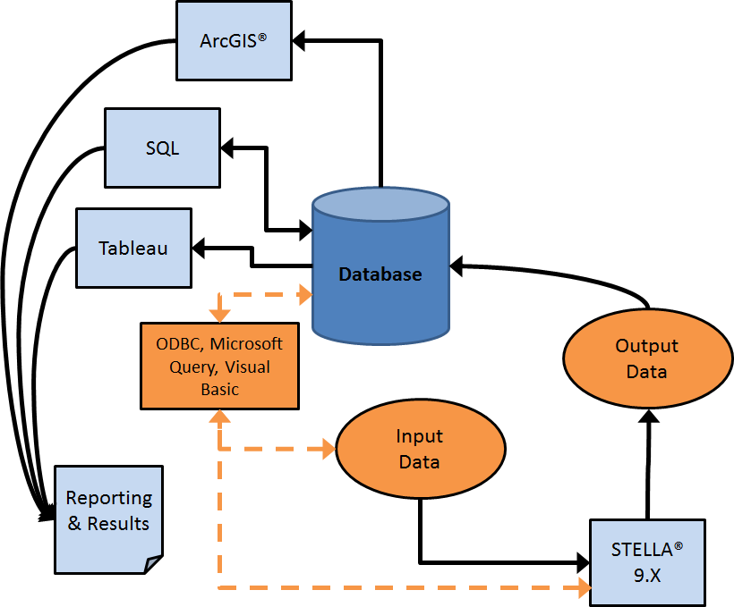

**Figure S2.** Detailed water footprinting model, data processing and management diagram.

4. Model Equations.

The water content at saturation (SAT), field capacity (FC) and wilting point (WP) are obtained by calculating the Van-Genuchten model for h = 0, 100 and 1500, respectively.(73)

*SAT= qr + (qs - qr) / (1 + (a * 0) ^ n) ^ m = qs*

*FC= qr + (qs - qr) / (1 + (a * 100) ^ n) ^ m*

*WP= qr + (qs - qr) / (1 + (a * 1500) ^ n) ^ m*

Where: *θs  = 0.81- 0.283(BD) + 0.001(Cl)*

*θr = 0.015+ 0.005(Cl) + 0.014(OM)*

*α= Exp( -2.486+ 0.025(S) - 0.351(OM) - 2.617(BD) - 0.023(Cl) )*

*n = Exp( 0.053- 0.009(S) - 0.0135(Cl) + 0.00015(S)² )*

*m = 1*

Sand (S) in %

Clay (Cl) in %

Bulk density (BD) in g/cm3

Organic matter (OM) in g/kg

Misc. Text for Likely Deletion

1. Correspondence to: Ethan Warner, National Renewable Energy Laboratory (NREL), 15013 Denver West Parkway, Golden, CO 80401. Phone: 303-384-7471, Fax: 303-275-4675. Email: ethan.warner@nrel.gov